

Summer Internship Training
(June 2025 - July 2025)

on

Java Maestro: Hands-on Training on Developing GUI Applications

Project Title: UNIT CONVERTER

Submitted by

Member 1: Manoj kumar Reg.No: 12313642
Member 2: Suraj kumar Reg.No : 12316616

Under the Guidance of

Mr. Ravi Kant Sahu
Assistant Professor,
School of Computer Science & Engineering



Lovely Professional University
Jalandhar - Delhi G.T. Road, Phagwara, Punjab (India) - 144411

Project Code

import javax.swing.*;
import java.awt.*;
import java.awt.event.*;

public class UnitConverterApp extends JFrame implements ActionListener {
JComboBox<String> categoryBox, fromUnitBox, toUnitBox;
JTextField inputField, outputField;
JLabel imageLabel;

String[] categories = {"Length", "Weight", "Volume", "Temperature", "Time"};
String[] iconPaths = {"length.jpg", "weight.jpg", "volume.jpg", "temperature.jpg", "time.jpg"};

String[][] units = {
{"Meter", "Kilometer", "Centimeter", "Millimeter", "Feet", "Inch"},
{"Gram", "Kilogram"},
{"Litre", "Millilitre"},
{"Celsius", "Fahrenheit", "Kelvin"},
{"Second", "Minute", "Hour", "Day"}
};

public UnitConverterApp() {
setTitle("Units Converter");
setSize(900, 600);
setIconImage(new ImageIcon("unit.jpg").getImage());

setLayout(null);
setDefaultCloseOperation(EXIT_ON_CLOSE);
getContentPane().setBackground(new Color(245, 245, 245));
setLocationRelativeTo(null);

JLabel title = new JLabel("Unit Converter", JLabel.CENTER);
title.setFont(new Font("Arial", Font.BOLD, 36));
title.setBounds(300, 20, 300, 50);
add(title);

JLabel categoryLabel = new JLabel("Select Category");
categoryLabel.setFont(new Font("Arial", Font.PLAIN, 20));
categoryLabel.setBounds(380, 90, 200, 30);
add(categoryLabel);

categoryBox = new JComboBox<>(categories);
categoryBox.setBounds(340, 130, 220, 30);
categoryBox.setFont(new Font("Arial", Font.PLAIN, 16));
add(categoryBox);

// Add image label next to category combo box
imageLabel = new JLabel();
imageLabel.setBounds(580, 120, 50, 50); // give space
add(imageLabel);

JLabel fromLabel = new JLabel("From Unit");
fromLabel.setFont(new Font("Arial", Font.PLAIN, 18));
fromLabel.setBounds(150, 190, 120, 25);
add(fromLabel);

fromUnitBox = new JComboBox<>();
fromUnitBox.setBounds(120, 220, 180, 30);
fromUnitBox.setFont(new Font("Arial", Font.PLAIN, 16));
add(fromUnitBox);

JLabel toLabel = new JLabel("To Unit");
toLabel.setFont(new Font("Arial", Font.PLAIN, 18));
toLabel.setBounds(630, 190, 120, 25);
add(toLabel);

toUnitBox = new JComboBox<>();
toUnitBox.setBounds(600, 220, 180, 30);
toUnitBox.setFont(new Font("Arial", Font.PLAIN, 16));
add(toUnitBox);

JLabel inputLabel = new JLabel("Input Value");
inputLabel.setFont(new Font("Arial", Font.PLAIN, 18));
inputLabel.setBounds(150, 280, 150, 25);
add(inputLabel);

inputField = new JTextField();
inputField.setBounds(120, 310, 180, 30);
inputField.setFont(new Font("Arial", Font.PLAIN, 16));
add(inputField);

JLabel outputLabel = new JLabel("Converted Value");
outputLabel.setFont(new Font("Arial", Font.PLAIN, 18));
outputLabel.setBounds(600, 280, 180, 25);
add(outputLabel);

outputField = new JTextField();
outputField.setBounds(600, 310, 180, 30);
outputField.setFont(new Font("Arial", Font.PLAIN, 16));
outputField.setEditable(false);
add(outputField);

JButton convertBtn = new JButton("Convert");
convertBtn.setBounds(370, 390, 150, 45);
convertBtn.setBackground(new Color(0, 123, 131));
convertBtn.setForeground(Color.WHITE);
convertBtn.setFont(new Font("Arial", Font.BOLD, 18));
add(convertBtn);

categoryBox.addActionListener(e -> {
updateUnits();
updateCategoryImage();
});
convertBtn.addActionListener(this);

updateUnits();
updateCategoryImage();

setVisible(true);
}

void updateUnits() {
int index = categoryBox.getSelectedIndex();
fromUnitBox.removeAllItems();
toUnitBox.removeAllItems();
for (String unit : units[index]) {
fromUnitBox.addItem(unit);
toUnitBox.addItem(unit);
}
}

void updateCategoryImage() {
int index = categoryBox.getSelectedIndex();
if (index >= 0 && index < iconPaths.length) {
ImageIcon icon = new ImageIcon(iconPaths[index]);
if (icon.getIconWidth() <= 0) {
System.out.println("⚠️ Image not found: " + iconPaths[index]);
imageLabel.setIcon(null);
} else {
Image img = icon.getImage().getScaledInstance(40, 40, Image.SCALE_SMOOTH);
imageLabel.setIcon(new ImageIcon(img));
}
}
}

public void actionPerformed(ActionEvent e) {
try {
double input = Double.parseDouble(inputField.getText());
int category = categoryBox.getSelectedIndex();
String from = (String) fromUnitBox.getSelectedItem();
String to = (String) toUnitBox.getSelectedItem();

double result = convert(category, input, from, to);
outputField.setText(String.format("%.4f", result));
} catch (Exception ex) {
JOptionPane.showMessageDialog(this, "Enter valid input");
}
}

double convert(int category, double value, String from, String to) {
if (category == 3) {
return convertTemperature(value, from, to);
}

double f1 = 1, f2 = 1;
switch (category) {
case 0: f1 = lengthFactor(from); f2 = lengthFactor(to); break;
case 1: f1 = weightFactor(from); f2 = weightFactor(to); break;
case 2: f1 = volumeFactor(from); f2 = volumeFactor(to); break;
case 4: f1 = timeFactor(from); f2 = timeFactor(to); break;
}
return value * (f1 / f2);
}

double convertTemperature(double value, String from, String to) {
double celsius = switch (from) {
case "Celsius" -> value;
case "Fahrenheit" -> (value - 32) * 5 / 9;
case "Kelvin" -> value - 273.15;
default -> value;
};

return switch (to) {
case "Celsius" -> celsius;
case "Fahrenheit" -> (celsius * 9 / 5) + 32;
case "Kelvin" -> celsius + 273.15;
default -> celsius;
};
}

double lengthFactor(String u) {
return switch (u) {
case "Meter" -> 1;
case "Kilometer" -> 1000;
case "Centimeter" -> 0.01;
case "Millimeter" -> 0.001;
case "Feet" -> 0.3048;
case "Inch" -> 0.0254;
default -> 1;
};
}

double weightFactor(String u) {
return switch (u) {
case "Gram" -> 1;
case "Kilogram" -> 1000;
default -> 1;
};
}

double volumeFactor(String u) {
return switch (u) {
case "Litre" -> 1;
case "Millilitre" -> 0.001;
default -> 1;
};
}

double timeFactor(String u) {
return switch (u) {
case "Second" -> 1;
case "Minute" -> 60;
case "Hour" -> 3600;
case "Day" -> 86400;
default -> 1;
};
}

public static void main(String[] args) {
new UnitConverterApp();
}
}

Project Screenshots

//Screenshots (Minimum 3) of all the Project Screens with Figure Details as shown below

Figure 1: calculation of lengths
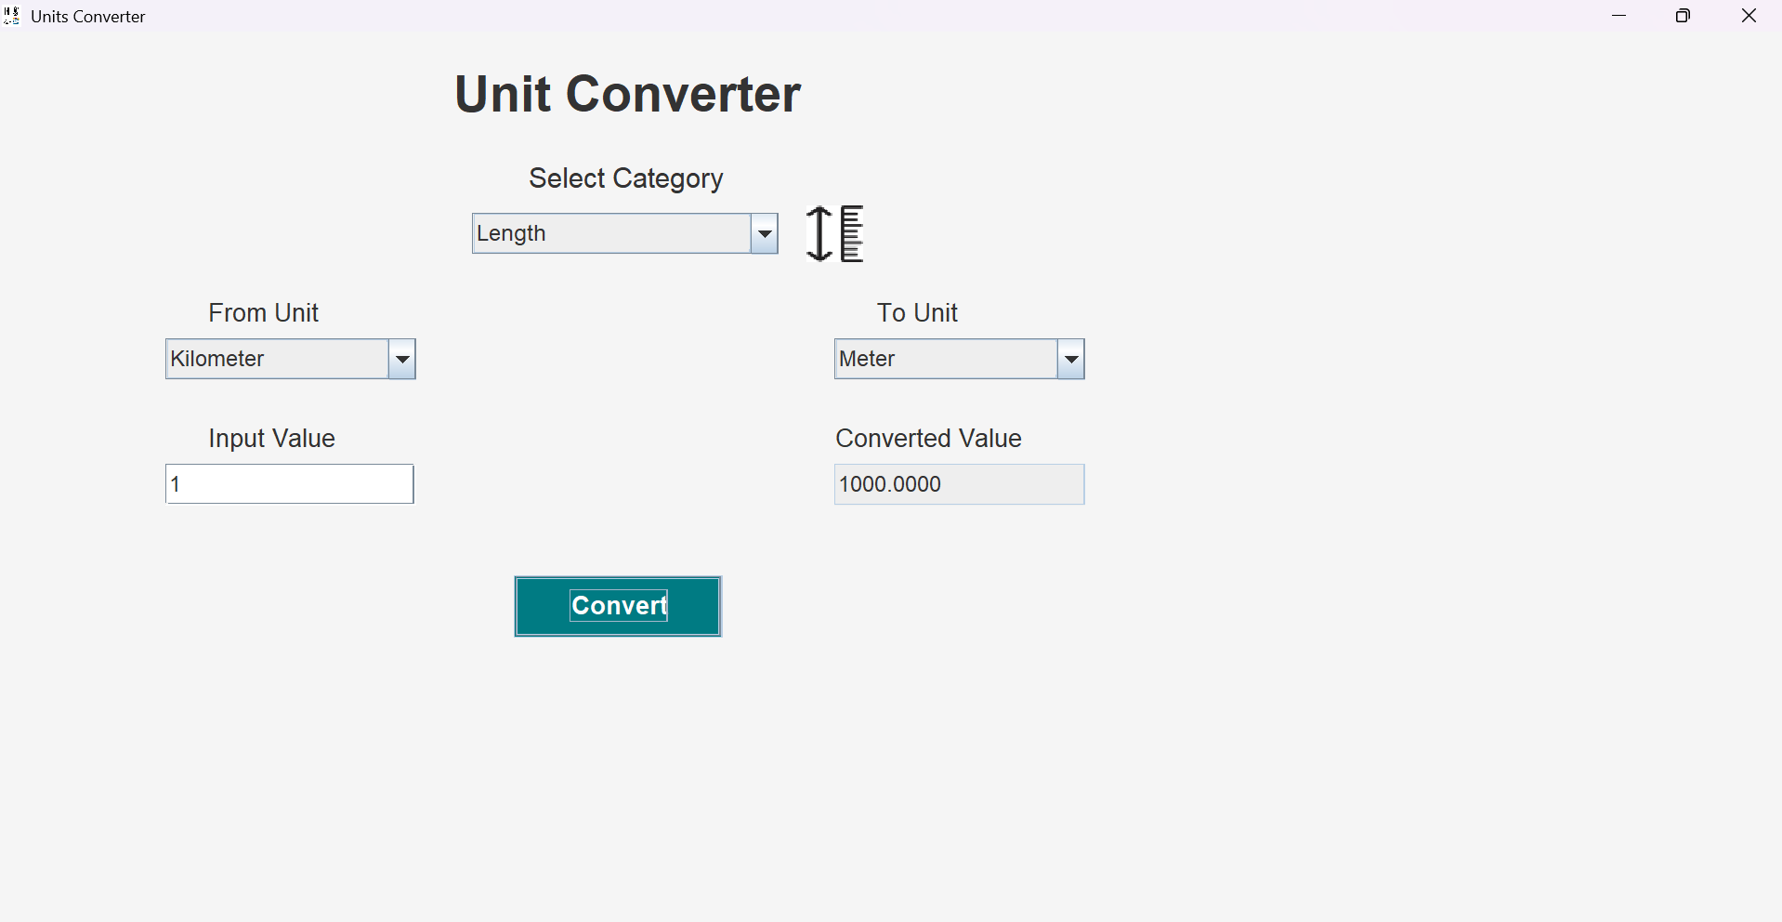

Figure 2: calculation of weight
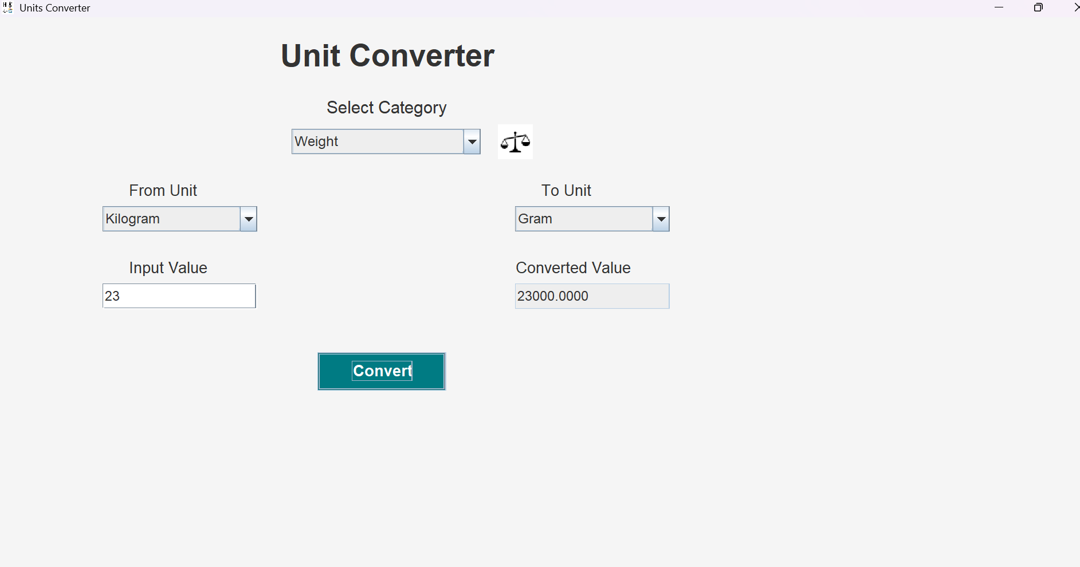

Figure 3: calculation of time
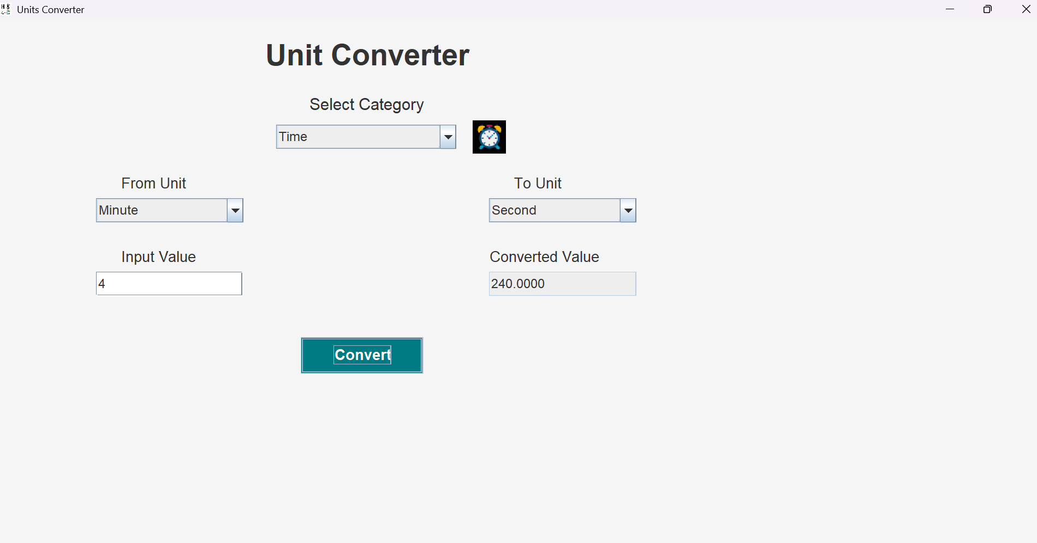

Figure 4: calculation of temperature
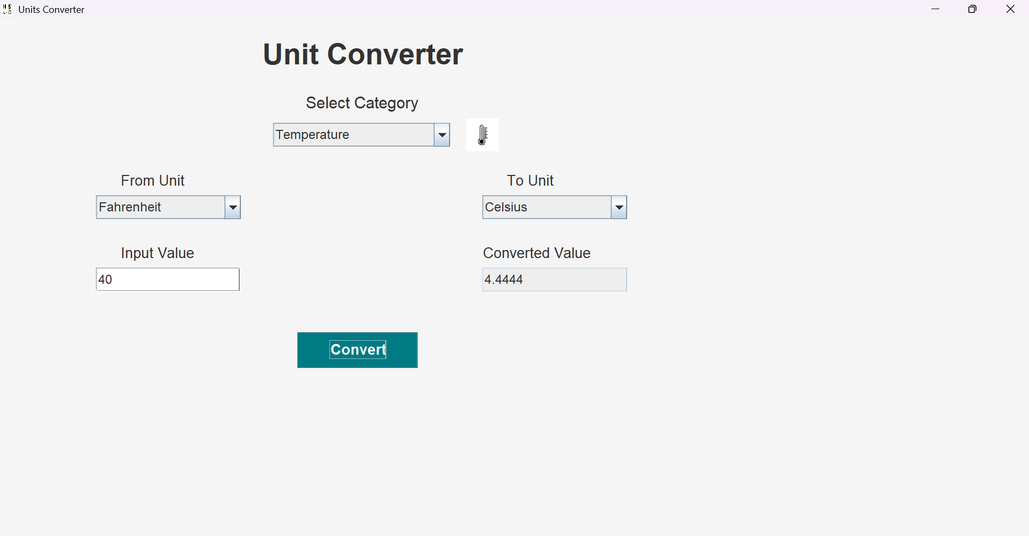

URL of the Project Demo Video: https://youtu.be/RGQpctb4kTA

